Week 9 — Computer Networks
Mobile Telephone Systems • Fast Ethernet • Gigabit Ethernet
Beginner-Friendly Notes — All Topics Covered

1. Mobile Telephone System (Generations)
Mobile networks evolved through 4 generations. Each generation brought faster speed and better features.

Gen | Name | Era | Voice/Data | Modulation | Example
1G | First Generation | 1980s | Analog voice only | FM (Frequency Modulation) | AMPS
2G | Second Generation | 1990s | Voice + Digital data (SMS) | QPSK | GSM
3G | Third Generation | 2000s | Digital voice + internet | CDMA (W-CDMA) | UMTS
4G | Fourth Generation | 2010s | Everything is data (VoLTE) | OFDM | LTE

💡 Simple way to remember: 1G = voice only → 2G = voice + SMS → 3G = internet → 4G = fast internet + video calls.

✅ Key Takeaways
- 1G was analog. No internet, no text. Just voice calls.
- 2G introduced digital signals and SMS messaging.
- 3G brought mobile internet browsing.
- 4G (LTE) made video streaming and fast data possible.
- Each generation uses a different modulation method to send data over radio waves.

2. AMPS — Advanced Mobile Phone System (1G)
AMPS was the first mobile phone system, used in the USA from the 1980s. It divided the coverage area into small zones called cells
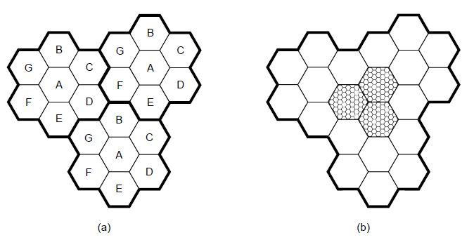
Fig 1: AMPS cell structure — each hexagon is a cell. Adjacent cells use different frequencies to avoid interference.

How AMPS Uses Frequencies
- Frequencies not reused in adjacent cells — prevents two nearby calls from interfering.
- Smaller cells = more users — if an area gets crowded, split the cells into smaller ones.
- 832 full-duplex channels — full-duplex means you can talk AND listen at the same time (like a normal phone call).
- Transmission: 824–849 MHz / Reception: 869–894 MHz — separate frequency bands so sending and receiving don't clash.

4 Types of AMPS Channels
- Control (base → mobile): tower sends system management info to phones.
- Paging (base → mobile): tower rings your phone when someone calls you.
- Access (bidirectional): used for call setup and channel assignment.
- Data (bidirectional): carries the actual voice, fax, or data.

✅ Key Takeaways
- AMPS = 1G. Analog voice only. No data, no SMS.
- Coverage area is divided into hexagonal cells.
- Adjacent cells use different frequencies to prevent interference.
- 832 full-duplex channels; separate TX (824-849 MHz) and RX (869-894 MHz) bands.
- 4 channel types: Control, Paging, Access, Data.

3. GSM — Global System for Mobile Communications (2G)
GSM was the 2G standard, deployed from the 1990s. It introduced digital signals, making voice clearer and enabling SMS messages. GSM is still used today as a fallback system.

GSM Architecture
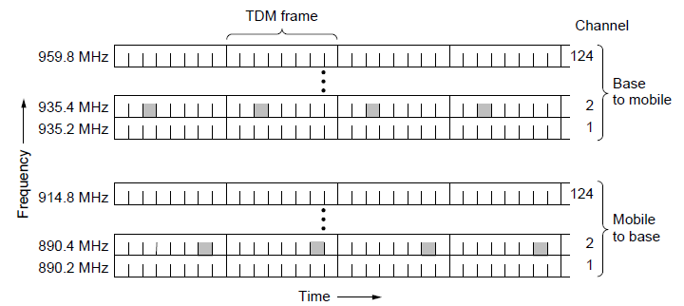
Fig 2: GSM Mobile Network Architecture — from your phone (MS) all the way to the core network.
Key components:
- MS (Mobile Station) — your phone.
- BSC (Base Station Controller) — controls a group of towers.
- MSC (Mobile Switching Center) — the brain. Routes calls between users.
- HLR (Home Location Register) — permanent database of your subscriber info.
- VLR (Visitor Location Register) — temporary database tracking you when roaming.
- AC (Authentication Center) — verifies your identity (prevents fraud).
- IMSI — your permanent unique ID (like a national ID for your SIM). TMSI — temporary ID used over the air to protect your real IMSI.
- LAI (Location Area Identity) — identifies which geographic zone you're currently in.

GSM Channels: 124 Frequencies × 8 Time Slots
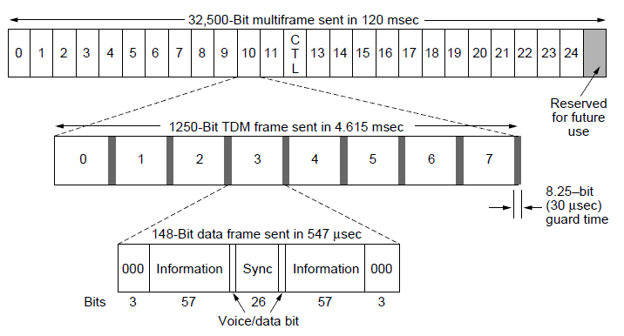
Fig 3: GSM frame structure — 124 frequency channels, each split into 8 TDM time slots. 8 users share one frequency.
GSM uses TDM (Time Division Multiplexing). Each frequency channel is divided into 8 time slots. So 8 different calls share one frequency — they take turns so fast it feels continuous. Like 8 people sharing 1 lane, taking rapid turns.

✅ Key Takeaways
- GSM = 2G. Digital voice + SMS. Still widely used as fallback.
- IMSI = your permanent ID. TMSI = temporary air-interface ID (protects privacy).
- 124 frequency channels × 8 TDM slots = up to 992 simultaneous calls per area.
- HLR stores permanent info. VLR stores temporary location info.
- MSC routes all calls. BSC controls multiple towers.

4. Mobile Originating Call (MOC)
An MOC is what happens when YOU make a call. It looks simple — dial a number, press call — but the network runs through 9 steps.
- Channel Request: Your phone (MS) asks the network for a signaling channel to set up the call.
- Request to VLR: After getting the channel, your phone sends its TMSI (or IMSI) and location (LAI) to the VLR.
- Get Auth Triples: VLR asks the AC (via HLR) for authentication credentials (called 'triples').
- Security Checks: VLR runs 4 checks — Authentication, Encryption start, IMEI check (optional), TMSI re-allocation (optional).
- Setup Info to MSC: Your phone sends the number you dialed and service type to the MSC.
- VLR Permission Check: MSC asks VLR — 'Is this subscriber allowed to make this call?' VLR checks subscription.
- MSC Assigns Traffic Channel: If permitted, MSC tells the BSC to assign a Traffic Channel (TCH) — the actual voice path.
- BSC Assigns TCH: BSC assigns the traffic channel to your phone.
- Call Connected: MSC connects you to the person you called. Their phone rings!

✅ Key Takeaways
- MOC = Mobile Originating Call — when YOU are the one making the call.
- TMSI is sent instead of IMSI to protect your real identity over the air.
- Authentication prevents fraud before any call is allowed.
- BSC assigns the actual voice channel (TCH). MSC routes the call.
- 9 steps happen in seconds, invisible to the user.

5. UMTS — Universal Mobile Telecommunications System (3G)
UMTS is the 3G standard, deployed from 2000s. It was built to bring real internet access to mobile phones, not just voice and SMS.

IMT-2000 Goals (What 3G Was Designed to Support)
- High-quality voice calls — clearer than 2G.
- Messaging — unified SMS, email, fax, chat.
- Multimedia — music, videos, TV on your phone.
- Internet access — web browsing with audio and video.

Key Technology: CDMA (W-CDMA)
3G uses CDMA (Code Division Multiple Access). Instead of separate time slots (GSM) or separate frequencies (AMPS), CDMA gives each user a unique code. All users transmit simultaneously on the same frequency — their unique codes separate them. It's like many people talking in a room, each in a different language.

Handoff — Moving Between Cells
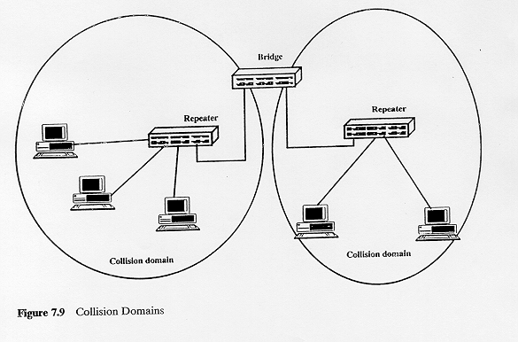
Fig 4: Soft vs Hard Handoff — (a) before, (b) during, (c) after handoff. Soft handoff connects to new tower before leaving old one.
- Hard handoff — disconnect from old tower, then connect to new one. Brief drop possible.
- Soft handoff (3G) — connected to TWO towers simultaneously during the transition. No interruption. Smoother.

✅ Key Takeaways
- UMTS = 3G. Designed for mobile internet, multimedia, and better voice.
- Uses W-CDMA: unique codes per user — all share same frequency/time.
- IMT-2000 defined the service goals for 3G globally.
- Soft handoff: connect to new cell before leaving old one — zero drops.

6. LTE — Long Term Evolution (4G)
LTE is the 4G standard, deployed from 2010. In 4G, everything is data — even voice calls are sent as data packets (called VoLTE: Voice over LTE). This is what most smartphones use today.

Key Technology: OFDM
OFDM (Orthogonal Frequency Division Multiplexing) splits one channel into many tiny sub-channels called subcarriers. Data is sent on all of them at once. Think of it as downloading a file through hundreds of tiny pipes simultaneously instead of one big pipe — much faster and more efficient.

Feature | 1G | 2G | 3G | 4G
Speed | ~2.4 kbps | ~384 kbps | ~2 Mbps | 100+ Mbps
Voice type | Analog | Digital | Digital | VoIP (data)
Data | None | SMS only | Mobile internet | Full broadband
Modulation | FM | QPSK | CDMA | OFDM
Era | 1980s | 1990s | 2000s | 2010s

✅ Key Takeaways
- LTE = 4G. Everything — including voice — is digital data.
- Uses OFDM: many parallel sub-channels = very high speed.
- Speeds of 100+ Mbps enable HD video streaming on phones.
- Voice over LTE (VoLTE) = phone calls treated like a data stream.

7. Fast Ethernet (100BASE-T) — IEEE 802.3u
Fast Ethernet runs at 100 Mbps — 10× faster than original 10 Mbps Ethernet. It was standardized in 1995 as IEEE 802.3u. The key innovation is MII (Media Independent Interface), which allows the same MAC chip to work with different cable types.

Architecture (MII Layers)
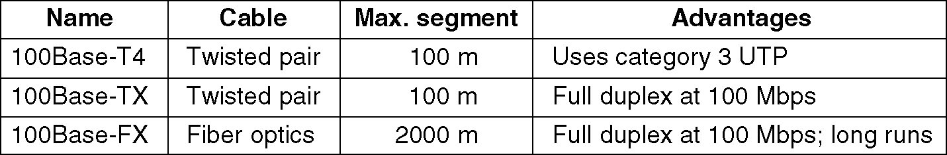
Fig 5: Fast Ethernet architecture — LLC → MAC → MII → Physical layer. MII is the separation point between MAC and cable type.
- LLC — Logical Link Control. Controls data frames.
- MAC — Media Access Control. Decides who sends and when.
- MII (Media Independent Interface) — key innovation. MAC doesn't need to know if the cable is copper or fiber. It always talks through MII.
- Convergence Sublayer — adapts MAC to different physical standards.
- Media Dependent Sublayer — handles the specific cable-type details.

Three Choices via MII
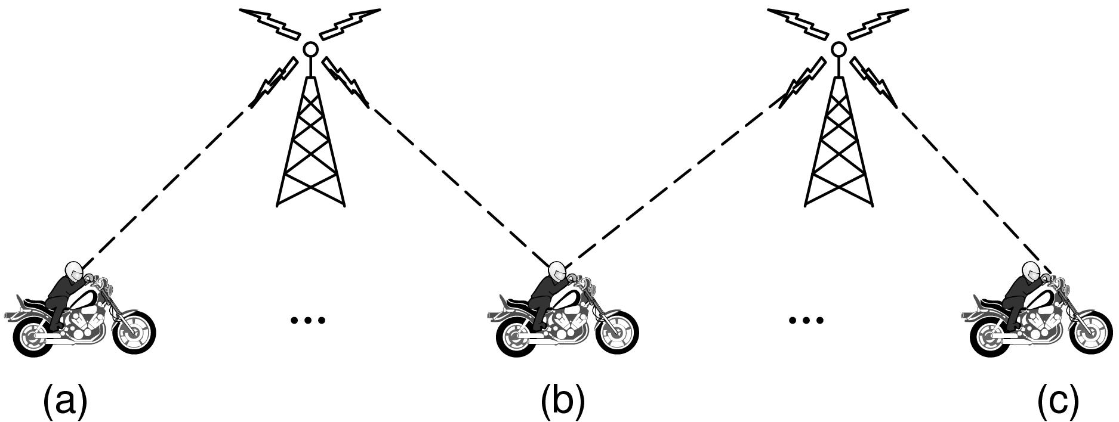
Fig 6: Fast Ethernet 3 cable choices — 100BASE-TX (Cat 5 copper), 100BASE-T4 (Cat 3 copper), 100BASE-FX (fiber).

✅ Key Takeaways
- Fast Ethernet = 100 Mbps. Standard: IEEE 802.3u (1995).
- MII = Media Independent Interface — same MAC works with any cable type.
- Three physical media choices: 100BASE-TX, 100BASE-T4, 100BASE-FX.
- UTP cable has 30 MHz limit — Manchester encoding won't work at 100 Mbps. So we use 4B/5B or 8B/6T instead.

8. IEEE 802.3 Ethernet Standards (Reference Table)
These are all the major Ethernet standards. Naming format: [speed]BASE-[type]. For example, 100BASE-TX = 100 Mbps, baseband, twisted pair.

Standard | Speed | Medium | Max (Half) | Max (Full)
10Base5 | 10 Mb/s | Thick coax | 500 m | n/a
10Base2 | 10 Mb/s | Thin coax | 185 m | n/a
10Base-T | 10 Mb/s | Cat 3 UTP (2 pair) | 100 m | 100 m
10Base-FL | 10 Mb/s | Optical fiber | 2000 m | >2000 m
100BASE-TX | 100 Mb/s | Cat 5 UTP (2 pair) | 100 m | 100 m
100BASE-FX | 100 Mb/s | Optical fiber | 412 m | 2000 m
100BASE-T4 | 100 Mb/s | Cat 3 UTP (4 pair) | 100 m | n/a
1000BASE-SX | 1 Gb/s | Multimode fiber (850nm) | 275 m | 275 m
1000BASE-LX | 1 Gb/s | Single/Multi fiber (1300nm) | 316–5000 m | 550–5000 m
1000BASE-CX | 1 Gb/s | Shielded copper (twinax) | 25 m | 25 m
1000BASE-T | 1 Gb/s | Cat 5 UTP (4 pair) | 100 m | 100 m

9. 100BASE-TX
100BASE-TX is the most common Fast Ethernet standard — the regular Cat 5 cable you see in offices. Two pairs: one for sending, one for receiving.

Encoding: 4B/5B + MLT-3
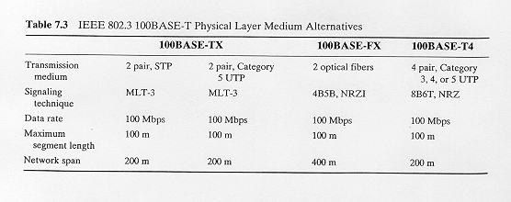
Fig 7: NRZI and MLT-3 encoding. NRZI transitions on '1' bits; MLT-3 cycles through +V → 0 → -V → 0, reducing signal bandwidth.
Problem: UTP cable has a 30 MHz bandwidth limit. Sending raw 100 Mbps binary would need 50 MHz — too high. Solution: use smart encoding.
- 4B/5B encoding — converts every 4 data bits into 5 transmitted bits. The 5-bit codes are chosen to avoid long runs of 0s or 1s. This ensures regular signal transitions for the receiver to stay in sync.
- MLT-3 (Multi-Level Transmit-3) — uses 3 voltage levels (+V, 0, -V) instead of 2. This reduces the signal frequency needed to fit within the 30 MHz cable limit.
- Max distance: 100 m. Supports half-duplex and full-duplex.

✅ Key Takeaways
- 100BASE-TX: Cat 5 UTP, 2 pairs, 100 Mbps, max 100 m.
- 4B/5B: 4 data bits → 5 transmitted bits. Guarantees signal transitions.
- MLT-3: 3 voltage levels reduces frequency requirement to fit 30 MHz limit.
- NRZI: transitions only on '1' bits. Can cause problems with long strings of '0s'.
- 4B/5B + MLT-3 together solve the clock recovery and bandwidth problems.

10. 100BASE-T4
100BASE-T4 achieves 100 Mbps over older Cat 3 UTP cable (not Cat 5). It does this by using 4 wire pairs instead of 2.

How It Works
- 3 pairs carry data in both directions at 33.33 Mbps each (3 × 33.33 ≈ 100 Mbps).
- 1 pair is used for collision detection / carrier sense only.

8B/6T Encoding
- 8B/6T — every 8 data bits are converted into 6 ternary (3-level: +V, 0, -V) symbols before sending.
Signaling rate = 100 × (6/8) / 3 = 25 MHz — within Cat 3's bandwidth limit.
- Codewords chosen to be DC balanced — equal + and - voltages over time. Prevents voltage buildup (DC wander).
- All chosen codewords have at least 2 transitions — ensures clock recovery at receiver.
- 3⁶ = 729 possible codewords, only 256 needed — best ones are selected for balance and transitions.

✅ Key Takeaways
- 100BASE-T4: Cat 3 UTP, 4 pairs, 100 Mbps, max 100 m.
- 8B/6T: 8 bits → 6 ternary symbols (3 levels: +V, 0, -V).
- Signaling rate = 25 MHz — within Cat 3 cable limit.
- 3 pairs carry data; 1 pair for collision detection.
- DC balanced codewords prevent voltage drift on the cable.

11. 100BASE-FX
100BASE-FX uses fiber optic cable instead of copper. Light pulses carry the data. Two fibers: one to send, one to receive.
- Maximum distance: 412 m (half-duplex) or 2000 m (full-duplex). Much longer than copper!
- Uses FDDI technology: converts 4B/5B encoded bits to NRZI optical signals.
- Immune to electrical interference — perfect for factories, outdoor links.
- More secure than copper — light doesn't radiate outside the fiber.

✅ Key Takeaways
- 100BASE-FX: optical fiber, 100 Mbps, up to 2000 m (full-duplex).
- Uses 4B/5B + NRZI encoding on light pulses.
- Ideal for longer distances or electrically noisy environments.

12. Fast Ethernet Repeaters and Switches
When you need to extend a network beyond 100 m or connect multiple segments, you use repeaters or switches.

Repeaters
- Class I Repeater — can connect different media types (e.g., copper to fiber). Slower. Only ONE allowed per collision domain.
- Class II Repeater — connects same media types only. Faster. Up to TWO allowed per collision domain.

Switches
A switch is smarter — it learns which device is on which port and only sends data where needed (not to everyone). Each port is its own collision domain.
- Full-duplex mode: send and receive simultaneously — no collisions possible.
- Auto-negotiation: switch automatically detects if a device runs at 10 or 100 Mbps.

Collision Domain
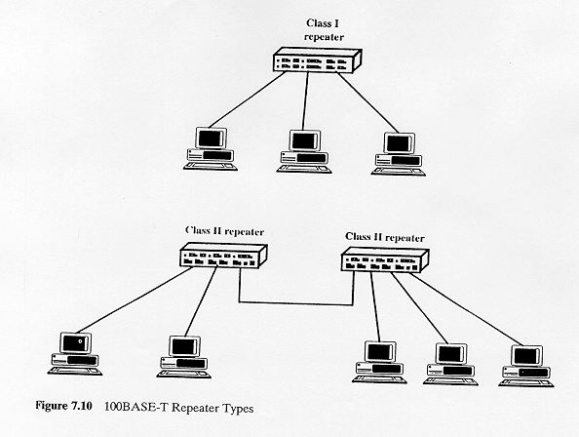
Fig 8: Collision Domains — repeater extends the same domain; switch creates a separate domain per port.
A collision domain is the area where two devices could transmit at the same time and collide. Hub = one big collision domain. Switch = separate collision domain per port — fewer collisions, more efficient.

✅ Key Takeaways
- Repeaters extend range but don't reduce collisions.
- Class I: 1 per domain, supports mixed media. Class II: 2 per domain, same media only.
- Switches separate collision domains — much more efficient than hubs.
- Full-duplex switch = zero collisions. Auto-negotiation handles speed mismatches.

13. Gigabit Ethernet — Overview
Gigabit Ethernet runs at 1000 Mbps (1 Gbps) — 10× faster than Fast Ethernet. It was standardized as IEEE 802.3z (fiber, 1998) and IEEE 802.3ab (copper, 1999). By end of 1997, 85% of all network connections already used Ethernet — so keeping the same frame format was critical.

Key Features
- Same Ethernet frame format — no changes to software or upper layers.
- Backward compatible with 10BASE-T and 100BASE-T.
- All connections are point-to-point.
- Uses CSMA/CD (half-duplex with hub) OR full-duplex (switch).
- Based on Fiber Channel (FC) physical layer technology.
- Uses 802.3x flow control.

Two Operating Modes
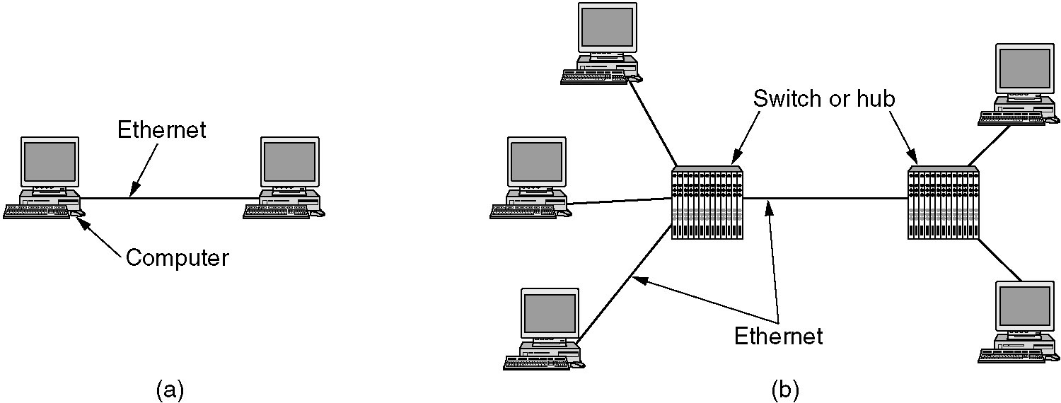
Fig 9: Gigabit Ethernet — (a) two-station, (b) multistation with hub or switch.
- Shared Hub (half-duplex) → uses CSMA/CD + Carrier Extension + Frame Bursting.
- Switch (full-duplex) → uses Buffered Distributor. No collisions. Best performance.

✅ Key Takeaways
- Gigabit Ethernet = 1 Gbps. IEEE 802.3z (fiber) and 802.3ab (copper).
- Same frame format as 10/100 Mbps Ethernet — software compatibility maintained.
- Hub mode: half-duplex with CSMA/CD (needs special MAC changes).
- Switch mode: full-duplex, no collisions, best throughput.

14. Gigabit Ethernet Architecture & GMII
Just like Fast Ethernet had MII, Gigabit Ethernet has GMII (Gigabit Media Independent Interface). It lets the same MAC work with fiber or copper physical layers.
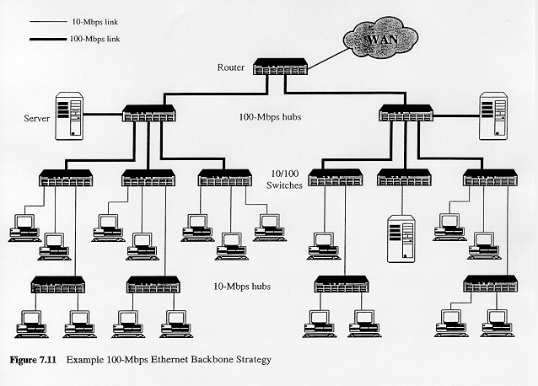
Fig 10: Gigabit Ethernet architecture — MAC → GMII → 1000BASE-X PHY (fiber) or 1000BASE-T PHY (copper).

Architecture Explained
- MAC (Media Access Control) — handles frames and CSMA/CD. Works the same regardless of physical media.
- GMII — optional interface. Separates MAC from physical layer. Allows any physical layer to plug in.
- 1000BASE-X PHY — fiber standards (SX, LX, CX). Uses 8B/10B encoding with auto-negotiation.
- 1000BASE-T PHY — copper UTP. Separate encoding for copper.

✅ Key Takeaways
- GMII = Gigabit Media Independent Interface. MAC works with any physical layer.
- Fiber Channel (FC) physical layer reused in Gigabit Ethernet — saves development time.
- Fiber variants use 8B/10B encoding. Copper (1000BASE-T) uses a different scheme.
- GMII is optional — some implementations connect MAC directly to PHY.

15. Gigabit Ethernet Physical Variants

1000BASE-SX — Short Wavelength Fiber
- Wavelength: 850 nm laser (770–860 nm range).
- Max distance: 275 m (multimode fiber only).
- 8B/10B encoding at 1.25 Gbps line rate.
- Cheaper than LX. Used for in-building or data center connections.

1000BASE-LX — Long Wavelength Fiber
- Wavelength: 1300 nm laser (1270–1355 nm range).
- Max distance: 550 m (multimode) or 5000 m (single-mode fiber).
- Supports single-mode AND multimode fiber. More expensive than SX.
- Used for inter-building or campus-wide connections.

1000BASE-CX — Short Haul Copper (Shielded)
- Cable: Shielded Twisted Pair (STP / 'twinax').
- Max distance: 25 m only — used inside a single wiring closet.
- 8B/10B encoding. Separate shielded pair for each direction.
- Now mostly replaced by 1000BASE-T for copper connections.

1000BASE-T — Twisted Pair Copper (Cat 5)
- Cable: 4 pairs of Cat 5, 6, or 7 UTP.
- Max distance: 100 m. Ratified June 1999 (IEEE 802.3ab).
- All 4 pairs used simultaneously in both directions — needs extensive DSP (digital signal processing).
- This is what allows gigabit speed on regular office Cat 5 cable.

Variant | Medium | Wavelength | Max Distance | Notes
1000BASE-SX | Multimode fiber | 850 nm | 275 m | Cheapest fiber option
1000BASE-LX | Single or Multimode fiber | 1300 nm | 5000 m (single-mode) | Long-distance fiber
1000BASE-CX | Shielded copper (STP) | n/a | 25 m | Wiring closet only
1000BASE-T | Cat 5 UTP (4 pairs) | n/a | 100 m | Standard office copper

✅ Key Takeaways
- SX = short wavelength fiber (850 nm), 275 m, cheapest, multimode only.
- LX = long wavelength fiber (1300 nm), up to 5 km on single-mode, more expensive.
- CX = shielded copper, only 25 m, used inside wiring closets.
- T = regular Cat 5 UTP, 100 m, 4 pairs — most common copper gigabit standard.
- SX, LX, CX all use 8B/10B encoding at 1.25 Gbps.

16. 8B/10B Encoding
8B/10B converts every 8 data bits → 10 transmitted bits. Used by 1000BASE-SX, LX, CX.
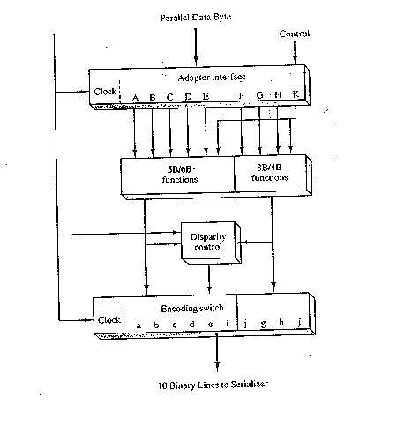
Fig 11: 8B/10B Encoder — converts 8-bit data into balanced 10-bit codes.

Why Is It Needed?
- Problem 1 — Clock recovery: Long strings of the same bit (e.g., 0000000) have no transitions. The receiver loses sync.
- Problem 2 — DC wander: Too many 1s or 0s builds up a voltage offset on the cable, causing errors.

How 8B/10B Fixes This
- 10-bit codes are chosen with 5 ones and 5 zeros (or 4/6 — never worse).
- Running Disparity: If two valid 10-bit codes exist for the same 8-bit data, pick the one that moves the count of 1s and 0s back toward balance.
- This guarantees transitions and DC balance in the signal.
- Overhead: 10 bits for 8 data bits = 25% overhead. Line rate = 1.25 Gbps → actual data rate = 1 Gbps.

✅ Key Takeaways
- 8B/10B: 8 data bits → 10 transmitted bits.
- Ensures balanced signal (equal 0s and 1s) — prevents DC wander.
- Guarantees signal transitions — receiver can always lock onto clock.
- Running Disparity: always choose the code that moves toward balance.
- 25% overhead: 1.25 Gbps line rate delivers 1 Gbps real data.

17. Carrier Extension
Carrier Extension solves a CSMA/CD problem specific to Gigabit Ethernet.

The Problem
In CSMA/CD, a sender must still be transmitting when the collision signal bounces back — otherwise it won't detect the collision. For 10BASE-T (2.5 km network), minimum frame = 64 bytes works fine. But Gigabit Ethernet has a max network of 200 m — the signal bounces back very quickly. A 64-byte frame finishes sending before the collision echo arrives. So we need a larger minimum slot time.

The Solution: Pad Small Frames
- Minimum slot time for Gigabit = 512 bytes.
- After a small frame ends, the sender keeps transmitting extra 'padding' called Carrier Extension bits — dummy control characters.
- Receiver discards carrier extension bits. Only real frame data is processed.
- Downside: mostly wasted bandwidth for small frames. Throughput barely better than Fast Ethernet for small frames.
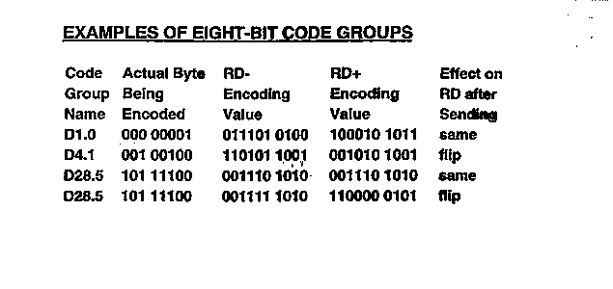
Fig 12: Carrier Extension — frame is followed by extension bits (R) to reach 512-byte minimum slot time.

✅ Key Takeaways
- CSMA/CD needs minimum transmission time so senders detect collisions.
- Gigabit Ethernet minimum slot time = 512 bytes (vs 64 bytes for 10/100 Mbps).
- Carrier Extension pads small frames with dummy bits to reach 512 bytes.
- Receiver discards extension bits — they carry no real data.
- Only needed in half-duplex mode (hub). Full-duplex needs no CSMA/CD.

18. Frame Bursting
Carrier Extension wastes bandwidth. Frame Bursting is the fix when a sender has multiple small frames to send at once — improving throughput 3×.

How It Works
- Sender wins CSMA/CD arbitration and starts sending normally.
- After the first frame, instead of releasing the network, sender fills the interframe gap with extension bits (96 bits) — keeping control.
- Sender immediately sends the next frame, then the next, etc.
- This continues until the total burst reaches 8192 bytes or the sender runs out of frames.
- Then the sender releases the network.
- Result: 3× better throughput for small-frame traffic compared to Carrier Extension alone.
- Uses 96 bits (9.6 µs gap equivalent) of extension bits between frames.

✅ Key Takeaways
- Frame Bursting: send multiple small frames in one burst without losing network control.
- Maximum burst size = 8192 bytes.
- Extension bits (96 bits) fill the interframe gap to maintain control.
- 3× throughput improvement for small-frame workloads.
- Only relevant in half-duplex hub mode.

19. Buffered Distributor
The Buffered Distributor is a new type of Gigabit Ethernet hub used in full-duplex mode. It eliminates collisions by buffering frames in memory.

How It Works
- Each port has an input FIFO queue and an output FIFO queue.
- When a frame arrives at an input queue, it's copied to ALL output queues — except the port it came from (no loopback).
- Because frames are buffered, there are no collisions on external links.
- All links are full-duplex — both sides can send simultaneously without collision.
- 802.3x flow control: if an input FIFO fills up, a PAUSE frame is sent to the connected device — tells it to stop briefly. Prevents buffer overflow.
- Distance restrictions removed: since collisions can't happen on external links, the old slot-time-based distance limits don't apply.

✅ Key Takeaways
- Buffered Distributor = smart hub with per-port FIFO input/output buffers.
- Frames buffered → no external collisions → no slot-time distance limits.
- All links run full-duplex — no CSMA/CD needed.
- 802.3x PAUSE frames handle congestion — sender pauses briefly when buffers fill.
- Bridges the gap between a traditional hub and a full layer-2 switch.

Quick Reference Cheat Sheet
Topic | One-Line Summary
1G / AMPS | Analog voice; FM; cells; 832 ch; no data
2G / GSM | Digital; QPSK; 124 freq × 8 TDM slots; SMS; IMSI/TMSI
MOC | 9-step call setup: Channel Req → Auth → TCH → Connect
3G / UMTS | CDMA; mobile internet; soft handoff; IMT-2000 goals
4G / LTE | OFDM; everything is data; VoLTE; 100+ Mbps
Fast Ethernet | 100 Mbps; MII; 3 choices: TX/T4/FX
100BASE-TX | Cat 5 UTP, 2 pair; 4B/5B + MLT-3; 100 m
100BASE-T4 | Cat 3 UTP, 4 pair; 8B/6T (ternary); 25 MHz signal rate; 100 m
100BASE-FX | Fiber; 4B/5B + NRZI; 2000 m full-duplex
Repeaters | Class I: 1/domain, mixed media. Class II: 2/domain, same media
Gigabit Ethernet | 1 Gbps; IEEE 802.3z/ab; point-to-point; FC physical layer
GMII | MAC works with any physical layer; optional interface
1000BASE-SX | 850 nm; multimode fiber; 275 m; cheapest fiber
1000BASE-LX | 1300 nm; single/multi fiber; up to 5 km
1000BASE-CX | Shielded copper; 25 m; wiring closet only
1000BASE-T | Cat 5 UTP, 4 pair; 100 m; needs heavy DSP
8B/10B | 8 bits → 10 bits; DC balance; running disparity; 25% overhead
Carrier Extension | Pads small frames to 512-byte slot time; half-duplex only
Frame Bursting | Multiple frames per burst; max 8192 bytes; 3× throughput
Buffered Distributor | Hub with FIFO buffers; full-duplex links; 802.3x flow control

